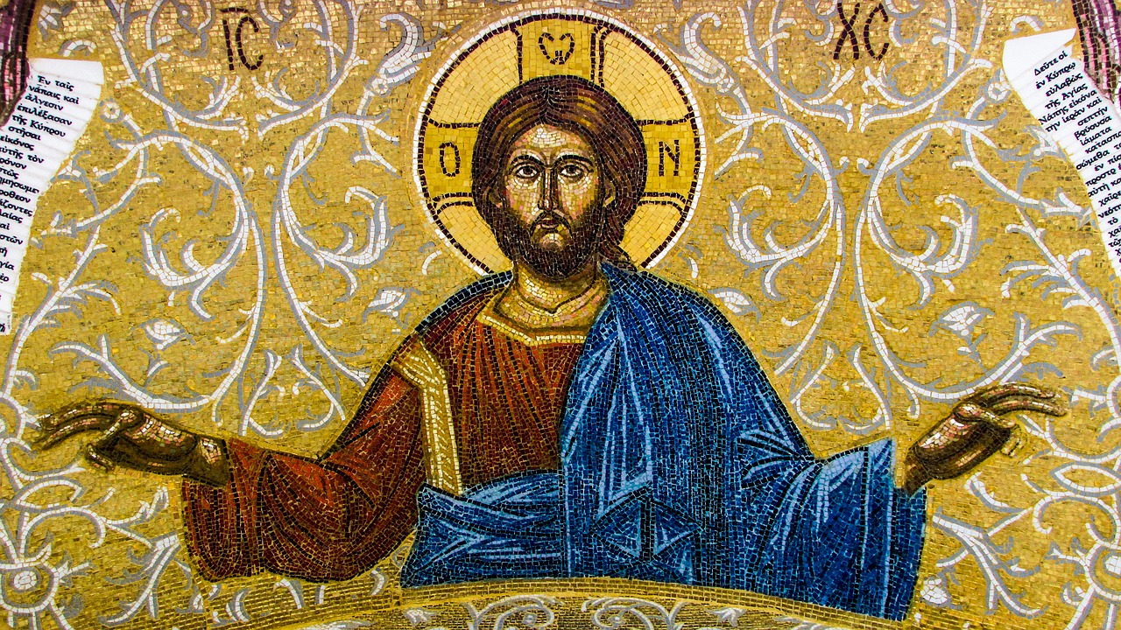**THE CATHOLIC PARISHES OF**

**CHIPPENHAM & CORSHAM**

**Website**: [**www.chippenham-and-corsham-catholics.org.uk**](http://www.chippenham-and-corsham-catholics.org.uk)

**Parish Priest: Fr Michael Fountaine**

**Presbytery: 30 Park Lane, Corsham, SN13 9LG**

**Tel: 07552859147**

**Email**: [**michael.fountaine@cliftondiocese.com**](mailto:michael.fountaine@cliftondiocese.com)

**Parish Administrator: Teresa Gosling**

**Tel: 07552859160**

**Parish Administration Emails:**

**[chippenham.stmary@ cliftondiocese.com](mailto:chippenham.stmary@%20cliftondiocese.com)**

**corsham.stpatrick@cliftondiocese.com**

**FOURTEENTH SUNDAY IN ORDINARY TIME**

**THE FOURTEENTH SUNDAY IN ORDINARY TIME A**

**5pm (Sat) (Ch) Vigil Mass *(F.Hodnett)***

**9am (Cor) Sung Mass *(Pro Populo)***

**11am (Ch) Sung Mass *(Pro Populo)***

**Monday 10th July Weekday in OT No Mass**

**Tuesday 11th July Feast of Saint Benedict, Abbot, Patron of Europe 12.10pm Mass (Ch) *()***

**Wednesday 12th July Weekday in OT**

**12pm Mass (Cor)**

**Thursday 13th July Weekday in OT 12pm Liturgy of the Word and Adoration (Cor)**

**Friday 14th July Weekday in OT**

**12.00pm Liturgy of the Word and Adoration (Cor)**

**Saturday 15th July Saint Bonaventure, Bishop, Doctor of the Church**

**4.15pm Eucharistic Adoration (Ch)**

**4.20pm – 4.50pm Confessions (Ch)**

**4.50pm Benediction (Ch)**

**THE FIFTEENTH SUNDAY IN ORDINARY TIME A**

**5pm (Sat) (Ch) Vigil Mass *()***

**9am (Cor) Sung Mass *(Pro Populo)***

**11am (Ch) Sung Mass *(Pro Populo)***

**TODAY’S SECOND COLLECTION STELLA MARIS (SEA SUNDAY)** Seafarers and fishers play a vital role in all of our lives, but they often work in difficult, hazardous conditions. In the last year, more crews have been abandoned by their employers than ever before. Many are still being denied the right to leave their ships for even a short break away from the relentless noise and pressure onboard. Many are reporting more stress and poorer mental health. Today we pray for all those who live and work at sea. Your support will make a big difference to seafarers and fishers in need. You can donate in church or [www.stellamaris.org.uk/donate](https://eur02.safelinks.protection.outlook.com/?url=http%3A%2F%2Fwww.stellamaris.org.uk%2Fdonate&data=05%7C01%7Ccorsham.stpatrick%40cliftondiocese.com%7Cbf1ad21ad16c4b0c76a808db70ae1652%7Cf10b8f13604e4fa29e1204a7fad22e94%7C0%7C0%7C638227665233102688%7CUnknown%7CTWFpbGZsb3d8eyJWIjoiMC4wLjAwMDAiLCJQIjoiV2luMzIiLCJBTiI6Ik1haWwiLCJXVCI6Mn0%3D%7C3000%7C%7C%7C&sdata=pXA%2FS%2BJ3ND4WPeMSsOcKWZEDMTzOLDF9m8Fl%2FA7V4zU%3D&reserved=0), or text ‘SEA’ to 70460 to donate £5. This collection is vital to enable Stella Maris (formerly Apostleship of the Sea) to continue its work. Thank you.

**CONGRATULATIONS** to the 14 children from our Parishes who celebrated their First Holy Communion yesterday. Pray that they may now grow in Christ as they make their Holy Communion each week of their lives. We thank all our catechists for all their work in preparing the children for this special day in their lives.

**CONFIRMATION** Our parishes are hoping to celebrate the sacrament of Confirmation in the summer of 2024. Pope Francis has said, ‘If in Baptism it is the Holy Spirit who immerses us in Christ, then in Confirmation it is Christ who fills us with his Spirit, consecrating us as his witnesses, participants in the same principle of life and of mission, according to the design of the heavenly Father.’  If any of our young people or adults would like to begin this journey to Confirmation, please contact Teresa Gosling or have a chat with Fr Michael if you would like to know more.

**SINGING THE MASS** During the pandemic we were unable to sing and so many people said they missed being able to praise the Lord in this way. We were cautious in reintroducing congregational singing to maintain safety. Yet, for some time now the congregation has been able to sing the Mass, Psalm responses and hymns. It does seem as if we have forgotten how to sing! Please do pick up your hymn book and join in the singing! This is a major way we actively participate in the Mass. As St Augustine said, ‘He who sings, prays twice.’ Let us begin to pray twice again.

**WANT TO KNOW MORE ABOUT THE CATHOLIC FAITH?** Are you interested to know about the Catholic Faith? Would you like to be baptized, confirmed and receive the Eucharist? Would you like to become a Catholic? Do you know anyone who would like to know more about the Catholic Church? If so, our Rite of Christian Initiation of Adults (RCIA)/Journey in Faith might be an exciting journey of faith for you. We explore different aspects of the Catholic faith and the teachings of the Catholic Church. We listen to God’s word in Scripture, and we pray together. We hope to begin the RCIA program this autumn. Please let Fr Michael or our Administrator know if you are interested.

**AN INTRODUCTION TO SMALL GROUP FACILITATION** The department of Adult Education & Evangelisation is offering an opportunity for parishioners to develop the skills of small group facilitation in the context of Parish Pastoral Councils, RCIA, Prayer Groups, Confirmation Preparation, and any other parish groups. This short session will help us to develop an attitude of listening with the heart and sharing with generosity. It will provide participants with a model for rooting decision making in prayer and discernment and the tools necessary for effective facilitation. Please see the poster in the porch for venues or have a look at the Clifton Diocese website.

**FR MICHAEL** will be on retreat this coming week (back permitting!) A priest is required by the Church to take a retreat once a year for prayer and solitude. Please pray for him at this time and for the guidance of the Holy Spirit.

**AN ONLINE EVENT WITH CARDINAL TAGLE** Mission Unleashed: Embracing the Social Dimension of Evangelisation. Friday 14th July 7pm - 8.30pm.Please click [here for more information and to book your place](https://eur02.safelinks.protection.outlook.com/?url=https%3A%2F%2Fwww.bigmarker.com%2Fcafod%2Fevangelisation%3Futm_bmcr_source%3DCPC&data=05%7C01%7Cchippenham.stmary%40cliftondiocese.com%7Cff2b9ac40575486305b208db77cac8a0%7Cf10b8f13604e4fa29e1204a7fad22e94%7C0%7C0%7C638235485059761537%7CUnknown%7CTWFpbGZsb3d8eyJWIjoiMC4wLjAwMDAiLCJQIjoiV2luMzIiLCJBTiI6Ik1haWwiLCJXVCI6Mn0%3D%7C3000%7C%7C%7C&sdata=Yc7X9NU01zAiJFBtzuME4UoxPizgSqWuh9AjtU7ldtw%3D&reserved=0)

**ST VINCENT DE PAUL SOCIETY** helps our community, with phone chats, visits, taking elderly parishioners to church, shopping or giving help to families in need at Christmas. Thank you to those who donate using DONA. Unfortunately, donations are down since the pandemic. If you can give a little, this will enable the SVP to help further within our parish. We also collect via our red boxes and leave boxes on the tables. Thank you.

**CALLING ALL CATECHISTS** Do you have experience of RCIA, or would you like to be part of the catechetical team? Thank you to those who have volunteered, we have room for more on the team! Please speak to Fr Michael or Teresa Gosling for more details.

**PARISH BBQ** Sunday 23rd July at 3pm in St Patrick’s, Corsham. Please bring your own drinks/cups, chairs plus a salad or dessert to share. Burgers, sausages and rolls provided. Please book online for catering purposes. Go to [https://www.eventbrite.co.uk/e/parish-bbq-tickets-639817410097](https://eur02.safelinks.protection.outlook.com/?url=https%3A%2F%2Fwww.eventbrite.co.uk%2Fe%2Fparish-bbq-tickets-639817410097&data=05%7C01%7Ccorsham.stpatrick%40cliftondiocese.com%7C10852ded95de48401eb208db602b54c1%7Cf10b8f13604e4fa29e1204a7fad22e94%7C0%7C0%7C638209511441939925%7CUnknown%7CTWFpbGZsb3d8eyJWIjoiMC4wLjAwMDAiLCJQIjoiV2luMzIiLCJBTiI6Ik1haWwiLCJXVCI6Mn0%3D%7C3000%7C%7C%7C&sdata=hbMHnvFWyoF8kjtunJunBO8P06Bd1VZvm53P3k32ojs%3D&reserved=0) All welcome.

**LBGT** Mass for the LGBT+ community, family, friends 3pm on Sunday 15th July at St Nicholas of Tolentino. All are welcome.  This diocesan initiative offers a welcome and way of reconnecting for many estranged from the Church.

**HOLY COMMUNION OF THE SICK** If you are sick/housebound and would like to receive Holy Communion (or the Sacrament of the Sick) at home, please call or ask a member of your family to call Fr Michael or Teresa Gosling.

**SACRAMENT OF RECONCILIATION (CONFESSION)** Chippenham Saturday 4.20pm – 4.50pm and Corsham after Weekday Masses or by arrangement with Fr Michael.

**PLEASE REMEMBER IN YOUR PRAYERS THIS WEEK**

**The Sick:** Corsham: Richard Keat, Sheila Taylor, Christopher Browl, Lindsay Price. Chippenham: Brian Tuersley, Lydia Connell, David Lunt, Jon Taylor, Michael Kenny, Mike Merry, Nic Pollastrone, Anne Marie Naylor, Chris Rosario, James Carine, Michaela Finn, Eoin O Mahony, Alan Houghton, Elena Alberti. Pray for all suffering with Coronavirus, all in our hospitals, nursing homes and those who care for them.

**RIP Anniversaries:** Kath Verrinder, Ray Snow, Peggy Grant, Paul Robinson, Jonathan Brock

**The Holy Father’s Prayer July Intention:** We pray that Catholics may place the celebration of the Eucharist at the heart of their lives, transforming human relationships in a very deep way and opening to the encounter with God and all their brothers and sisters.

**Diocesan Prayer Link:** St Teresa of the Child Jesus, Filton; St Vincent de Paul, Southmead, Bristol

*In compliance with the requirements of GDPR permission must be sought from an individual (or next of kin) before their name can be added to a list of those who are sick. Do please advise us of any changes to be made to this list.*

*.*

*Clifton Diocese is a company limited by guarantee; registered in England and Wales under number 10462076. Registered Charity No. 1170168 Registered Office: St Ambrose, North Road, Leigh Woods, Bristol, BS8 3PW*

**July - The Month of the Precious Blood**

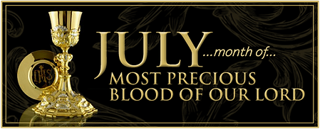

The month of July is dedicated to the Precious Blood. The feast of the Precious Blood of our Lord was instituted in 1849 by Pius IX, but the devotion is as old as Christianity. The early Fathers say that the Church was born from the pierced side of Christ, and that the sacraments were brought forth through His Blood.

"The Precious Blood which we venerate is the Blood which the Saviour shed for us on Calvary and reassumed at His glorious Resurrection; it is the Blood which courses through the veins of His risen, glorified, living body at the right hand of God the Father in heaven; it is the Blood made present on our altars by the words of Consecration; it is the Blood which merited sanctifying grace for us and through it washes and beautifies our soul and inaugurates the beginning of eternal life in it."

One of the oldest documents, outside of sacred scripture, from the first century of the Christian era of Pope St Clement I, dated about 96 A.D. says: "Let us fix our gaze on the Blood of Christ and realize how truly precious It is, seeing that it was poured out for our salvation and brought the grace of conversion to the whole world."

**Collect from the Mass of the Precious Blood**

"O God, who by the Precious Blood of your Only Begotten Son have redeemed the whole world, preserve in us the work of your mercy, so that ever honouring the mystery of our salvation, we may merit to obtain its fruits. Through Our Lord…

**A Prayer for Ukraine**

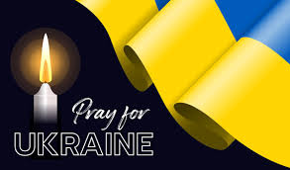

Loving God,  
We pray for the people of Ukraine,  
for all those suffering or afraid,  
that you will be close to them and protect them.

We pray for world leaders,  
for compassion, strength and wisdom to guide their choices.

We pray for the world  
that in this moment of crisis,  
we may reach out in solidarity  
to our brothers and sisters in need.

May we walk in your ways  
so that peace and justice  
become a reality for the people of Ukraine  
and for all the world.

Amen.

**THE WORD THIS WEEK**

THE FOURTEENTH SUNDAY IN ORDINARY TIME A

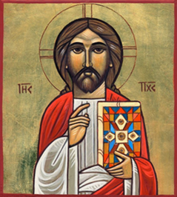

**First reading** Zechariah 9:9-10

*A reading from the prophet Zechariah*

The Lord says this:

Rejoice heart and soul, daughter of Zion!

Shout with gladness, daughter of Jerusalem!

See now, your king comes to you;

he is victorious, he is triumphant,

humble and riding on a donkey,

on a colt, the foal of a donkey.

He will banish chariots from Ephraim

and horses from Jerusalem;

the bow of war will be banished.

He will proclaim peace for the nations.

His empire shall stretch from sea to sea,

from the River to the ends of the earth.

The word of the Lord

**Responsorial Psalm** Psalm 144(145):1-2,8-11,13b-14

*I will bless your name for ever, O God my King.*

I will give you glory, O God my king,

I will bless your name for ever.

I will bless you day after day

and praise your name for ever.

The Lord is kind and full of compassion,

slow to anger, abounding in love.

How good is the Lord to all,

compassionate to all his creatures.

All your creatures shall thank you, O Lord,

and your friends shall repeat their blessing.

They shall speak of the glory of your reign

and declare your might, O God.

The Lord is faithful in all his words

and loving in all his deeds.

The Lord supports all who fall

and raises all who are bowed down.

**Second reading** Romans 8:9,11-13

*A reading from the letter of St Paul to the Romans*

Your interests are not in the unspiritual, but in the spiritual, since the Spirit of God has made his home in you. In fact, unless you possessed the Spirit of Christ you would not belong to him, and if the Spirit of him who raised Jesus from the dead is living in you, then he who raised Jesus from the dead will give life to your own mortal bodies through his Spirit living in you.

So then, my brothers, there is no necessity for us to obey our unspiritual selves or to live unspiritual lives. If you do live in that way, you are doomed to die; but if by the Spirit you put an end to the misdeeds of the body you will live.

The word of the Lord.

**Gospel Acclamation**

Mt11:25

Alleluia, alleluia!

Blessed are you, Father,

Lord of heaven and earth,

for revealing the mysteries of the kingdom

to mere children.

Alleluia!

**Gospel** Matthew 11:25-30

*A reading from the holy Gospel according to Matthew*

Jesus exclaimed, ‘I bless you, Father, Lord of heaven and of earth, for hiding these things from the learned and the clever and revealing them to mere children. Yes, Father, for that is what it pleased you to do. Everything has been entrusted to me by my Father; and no one knows the Son except the Father, just as no one knows the Father except the Son and those to whom the Son chooses to reveal him.

‘Come to me, all you who labour and are overburdened, and I will give you rest. Shoulder my yoke and learn from me, for I am gentle and humble in heart, and you will find rest for your souls. Yes, my yoke is easy and my burden light.’

The Gospel of the Lord