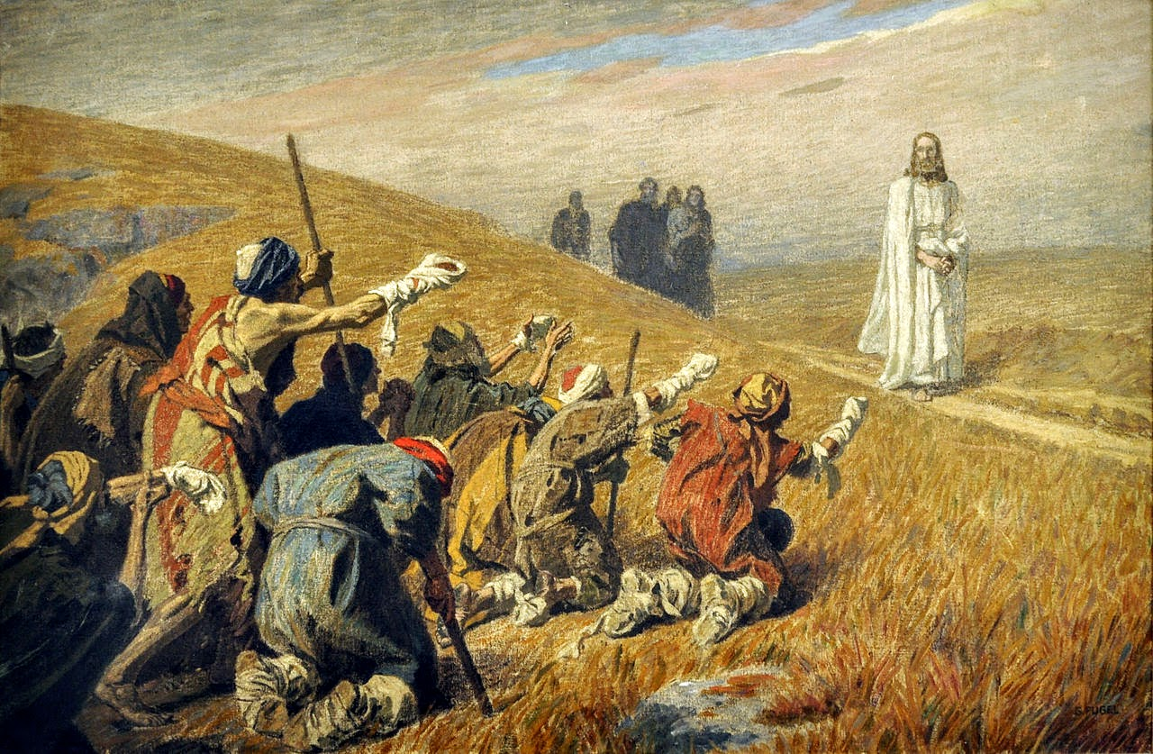**THE CATHOLIC PARISHES OF**

**CHIPPENHAM & CORSHAM**

**Website**: [**www.chippenham-and-corsham-catholics.org.uk**](http://www.chippenham-and-corsham-catholics.org.uk)

**Parish Priest: Fr Michael Fountaine**

**Presbytery: 30 Park Lane, Corsham, SN13 9LG**

**Tel: 07552859147**

**Email**: [**michael.fountaine@cliftondiocese.com**](mailto:michael.fountaine@cliftondiocese.com)

**Parish Administrator: Teresa Gosling**

**Tel: 07552859160**

**Parish Administration Emails:**

**[chippenham.stmary@ cliftondiocese.com](mailto:chippenham.stmary@ cliftondiocese.com)**

**corsham.stpatrick@cliftondiocese.com**

**Associate Priest: Mgr Keith Newton Tel: 07976585891**

**28TH SUNDAY IN ORDINARY TIME**

**12th October**

**5pm (Sat) Vigil Mass (Ch) *( For the Healing of a family tree)***

**9am (Cor) Sung Mass *(Pro Populo)***

**11am (Ch) Sung Mass *(Pro Populo)*  with Holy Baptismwith Children’s Liturgy**

**Monday 13th October**

**St Edward the Confessor No Mass**

**Tuesday 14th October**

**Weekday in Ordinary Time**

**12.10pm Mass (Ch) *(Fr Francis Kemsley)***

**Wednesday 15th October**

**St Teresa of Jesus, Virgin & Doctor of the Church**

**12pm Mass (Cor) *(Fr Millett)***

**Thursday 16th October**

**Weekday in Ordinary Time**

**\*11am* Mass *(Kathleen Power)* with Yr 4/5 St Mary’s School (Ch)**

***followed by Eucharistic Adoration***

**Friday 17th October**

**St Ignatius of Antioch, Bishop, Martyr**

**12.10pm Mass (Ch) *(Kevin Neeson)***

**Saturday 18th October**

**Feast of Saint Luke, Evangelist**

**2-4.15pm Eucharistic Adoration (Ch)**

**4.15pm–4.45pm (Sat) Co****nfessions**

**4.45pm Benediction (Ch)**

**29TH SUNDAY IN ORDINARY TIME**

**19th October**

**5pm (Sat) Vigil Mass (Ch) *(Simon Slaughter)***

**9am (Cor) Sung Mass *(Pro Populo) with Children’s Liturgy***

**11am (Ch) Sung Mass *(Pro Populo)***

**28TH SUNDAY OF THE YEAR C**

**RCIA - JOURNEY IN FAITH** Our new sessions began last week and continue this Wednesday, 15th October at 7pm in the parish office at St Mary’s. It is wonderful to see people wishing to know our Lord and his Church more fully. It is not too late to join the group, so do come along this week if you are interested. The subject this week is ‘The Existence of God’.

**ANNUAL MASS COUNT** **& REGISTRATION** This weekend is the last annual Mass count. There are many new members of our congregations. Please could you complete the registration form online, or in paper form, as under GDPR we are not allowed to communicate with you unless you have signed up to the register. This is especially important if you wish your child to receive the sacrament of Holy Communion next year. More info to follow.

**THIRD WEDNESDAY LUNCH CLUB** **AT ST PATRICK’S** will be held this Wednesday 15th October in the Hall after the 12pm Mass. All are very welcome.

**SVP LUNCH** Chippenham hosts a Parish lunch on Friday 24th October after 12.10pm Mass. Everyone is welcome. Please place your name and contact details (phone number or email address) on the sign-up sheet. We need 20 people to sign up to make this viable, if not will have to cancel the lunch, and you will be contacted after Tuesday 21st October. If you would like to help us, do contact Teresa.

**MISSIO** Next Sunday, 12th October, is World Mission Sunday. ‘Missionaries of Hope Among All Peoples’ is the theme. The Holy Father invites all Catholics to support Missio (the red box charity) – his charity for world mission – through a special collection. This day of prayer, solidarity and giving unites Catholics worldwide to share the Good News of God’s love which has the power to transform lives and heal our world. To donate, use the Missio envelopes, call 020 7821 9755 (office hours) or visit missio.org.uk to give a gift, set up a Direct Debit and Gift Aid your donation if possible.

**RENOVATION OF ST PATRICKS** Please take a look at the display in the Church which features the proposed works at St Patrick’s. There are some very interesting historic photos and Victorian drawings showing the progress of the use of the building from School to glove factory to Church.

**ONGOING WORKS AT ST MARY’S** There is much work happening behind the scenes at the moment on the Church, hall and presbytery as time has taken its toll on our buildings. Iron guttering has been replaced, brickwork has been repointed and cracks mended, doors have been repaired and painted, and caps have been placed on the presbytery chimneys. Roofing repairs have been done on all buildings with new soffits and facia boards. Often these very expensive repairs remain unseen, yet they are a vital part of the ongoing maintenance of our buildings. Work will be ongoing in other areas in the coming weeks.

**NEURODIVERSITY AND OUR FAITH** The Catholic Bishops’ Conference of England & Wales and Birmingham Newman University are conducting research into Neurodiversity and our Faith. If you're an adult neurodivergent Catholic or a Caregiver of a neurodivergent Catholic, we want to hear from you. Your experiences will help us to become more inclusive and responsive to your needs. To find out more and to fill in our short surveys look here: [www.godwhospeaks.uk/neurodivergent-catholic-surveys/](https://eur02.safelinks.protection.outlook.com/?url=https%3A%2F%2Fwww.godwhospeaks.uk%2Fneurodivergent-catholic-surveys%2F&data=05%7C02%7Cchippenham.stmary%40cliftondiocese.com%7Cbecdc7fcf9cd4edeb66e08de064640d2%7Cf10b8f13604e4fa29e1204a7fad22e94%7C1%7C0%7C638955096272839942%7CUnknown%7CTWFpbGZsb3d8eyJFbXB0eU1hcGkiOnRydWUsIlYiOiIwLjAuMDAwMCIsIlAiOiJXaW4zMiIsIkFOIjoiTWFpbCIsIldUIjoyfQ%3D%3D%7C0%7C%7C%7C&sdata=vO9tI8iuACgCaolvq9LSgEDeciTQ3irWRJdsOzbCyTU%3D&reserved=0) If you have any questions about this research, please do email Fleur at: [Fleur.Dorrell@CBCEW.Org.uk](mailto:Fleur.Dorrell@CBCEW.Org.uk)

**ENCOUNTER – CLIFTON CATHEDRAL** Saturday 19th October. Come and join us for another *Encounter* of God’s love and mercy. Mass at 9.30 followed by Adoration and Confessions. We will start at 10.30 and close at 1pm. There will be a time of praise and of listening to the Lord and each other.  Apostle Room, Cathedral Church of Ss Peter & Paul, Clifton Park, Bristol, BS8 3BX. All welcome. For more information email [pentecost@cliftondiocese.com](mailto:pentecost@cliftondiocese.com).

**THE CLIFTON EVANGELISATION NEWSLETTER** can be found on our diocesan website [www.cliftondiocese.com/clifton-evangelist/](http://www.cliftondiocese.com/clifton-evangelist/)

**THE NEWMAN CATHOLIC TRUST** is recruiting a Finance Manager (4 days per week). This is a role for a finance professional who combines technical skill with service, able to give leaders clarity and confidence as our family of schools grows. The closing date: 20th October 2025 and please apply using this link**:** [https://mynewterm.com/jobs/17561/EDV-2025-CNCET-13863](https://eur02.safelinks.protection.outlook.com/?url=https%3A%2F%2Fmynewterm.com%2Fjobs%2F17561%2FEDV-2025-CNCET-13863&data=05%7C02%7Cchippenham.stmary%40cliftondiocese.com%7Cce71032a68224014613d08ddfa7926fd%7Cf10b8f13604e4fa29e1204a7fad22e94%7C1%7C0%7C638942120454042413%7CUnknown%7CTWFpbGZsb3d8eyJFbXB0eU1hcGkiOnRydWUsIlYiOiIwLjAuMDAwMCIsIlAiOiJXaW4zMiIsIkFOIjoiTWFpbCIsIldUIjoyfQ%3D%3D%7C0%7C%7C%7C&sdata=iNz%2BjNeYanXj8gthZmwYLnTdf%2BZVs5eZvrblPt8C3Sg%3D&reserved=0)

**PRIMARY SCHOOL ADMISSIONS FOR 2026-27** If your child was born between 1st September 2021 and 31st August 2022, it is time to apply for a school place for admission from September 2026. Complete the application form available from the School Admissions team of Wiltshire County Council to access their online 2026-27 reception intake online (or contact them to request a paper form). Catholics should provide a copy of the baptism certificate to your preferred Catholic school. Closing date of 15th January 2026.

**NEXT QUIZ NIGHT** will be held at St Patrick’s Hall on Sat 22nd November at 7pm. More details to follow.

**NEXT JOINT PARISH PPC** will be held in Chippenham on 30th October at 7pm in the office.

**SACRAMENT OF RECONCILIATION** Corsham after weekday mass. Chippenham on Sat 4.15-4.45pm.

**PLEASE REMEMBER IN YOUR PRAYERS THIS WEEK**

**The Sick:** Corsham: Mo Brinn, Richard Keat, Anne Keat, Sheila Taylor, Christopher Browl, Lindsay Price, Robert Wilkins. Chippenham: Ann Sutton, David Lunt, Michael Kenny, Mike Merry, Nic Pollastrone, Victoria Kiss, Pamela Naylor, Anne Martin, Agnes Tegner, Michael Millard, Mary McIver. Pray for all in our hospitals, nursing homes and those who care for them.

**RIP Anniversaries:** Lewis Harlowe, Tony Tilbury, Geoffrey Marshall, Steve Arthur.

**For Peace:**  in Ukraine, Gaza and all the places of warfare throughout the world.

**The Holy Father’s October Intention:** Let us pray that, inspired by Saint Francis, we might experience our interdependence with all creatures who are loved by God and worthy of love and respect.

**Diocesan Prayer Link:** St Teresa of the Child Jesus, Filton; St Vincent de Paul, Southmead, Bristol.

*In compliance with the requirements of GDPR permission must be sought from an individual (or next of kin) before their name can be added to a list of those who are sick.*

*Do please advise us of any changes to be made to this list.*

*Diocese is a company limited by guarantee; registered in England and Wales under number 10462076. Registered Charity No. 1170168 Registered Office: St Ambrose, North Road, Leigh Woods, Bristol, BS8 3PW*

**October – The Month of the Holy Rosary.**

**Hail Mary, Full of Grace...**

On October 7th, the Church celebrates the memorial of Our Lady of the Holy Rosary. The memorial of Our Lady of the Rosary, was instituted to honour the  Blessed Virgin Mary for the Christian victory over the Turks at Lepanto on October 7th , 1571. Pope S. Pius V and all Christians had prayed the Rosary for victory. The Rosary, or the Psalter of the Blessed Virgin Mary, is a much loved devotion to Mary, the Mother of God. “The Rosary, though clearly Marian in character, is at heart a Christocentric prayer. In the sobriety of its elements, it has all the depth of the Gospel message in its entirety, of which it can be said to be a compendium” (St John Paul II. [Rosarium Virginis Mariae](https://www.catholicforlife.com/holy-rosary-powerful-weapon-arsenal-much-neglected/) – On the Most Holy Rosary). The Church invites all families to pray the Rosary for the mission of the Church and for peace.

In the gospel (Luke 11: 5-13), Jesus instructs his disciples on approach to prayers. Our persistent lifting up of our petitions to God draws us closer to God and opens our understanding of God’s actions as response to our prayers. We need to ask with expectant faith and confident trust, seek for God’s guidance and help in time of need, and persistently knock at God’s door of mercy and blessings. Together with awe, Mary teaches us today to turn our gaze upward, to trust and to entrust ourselves to the Lord. In doing this, we recognize we cannot do it on our own, that we are not the authors of our own destiny, that we are in need of others and that we are all together in need of God. The Lord never leaves us alone – he promised us this. But we must be the first to believe it by turning our gaze from the things of this earth and learning how to fix our gaze on heaven, from whence comes our help.

The trust we show by praying the Holy Rosary is a sign through which we recognize that God works through us and around us and, through Mary’s intercession, we can cultivate a “higher objective in life”. To believe is actually to give credit to the One who can do all things, to accept His help, to recognize that we cannot do everything on our own, to entrust ourselves to Him even when His plans do not correspond to ours, to the point of offering ourselves with trust: *“Behold, I am the handmaid of the Lord. May it be done to me according to your word”*.

**Asking Mary to pray with us and for us**

*Our Lady of the Rosary, you entrusted this holy prayer to Saint Dominic, and through him to the world. You are always attentive to the prayers of the Rosary and never fail to pour forth God’s grace in response. Please pray for me, that I will more deeply comprehend the power of the Rosary and will never fail in my duty to pray it. Our Lady of the Rosary, pray for us.*

****THE WORD THIS WEEK**

**28TH SUNDAY IN ORDINARY TIME C**

**First reading** **2 Kings 5:14-17**

*A reading from the Second Book of Kings*

In those days: Naaman the Syrian went down and dipped himself seven times in the Jordan, according to the word of Elisha, the man of God, and his flesh was restored like the flesh of a little child, and he was clean. Then he returned to the man of God, he and all his company, and he came and stood before him. And he said, ‘Behold, I know that there is no God in all the earth but in Israel; so accept now a present from your servant.’ But Elisha said, ‘As the Lord lives, before whom I stand, I will receive none.’ And Naaman urged Elisha to take it, but he refused. Then Naaman said, ‘If not, please let there be given to your servant two mule-loads of earth, for from now on your servant will not offer burnt offering or sacrifice to any god but the Lord.’

The Word of the Lord.

**Responsorial Psalm** **Ps 98(97)**

*The Lord has shown his salvation to the nations.*

O sing a new song to the Lord,

for he has worked wonders.

His right hand and his holy arm

have brought salvation.

The Lord has made known his salvation,

has shown his deliverance to the nations.

He has remembered his merciful love

and his truth for the house of Israel.

All the ends of the earth have seen

the salvation of our God.

Shout to the Lord, all the earth;

break forth into joyous song,

and sing out your praise.

**Second reading** **2 Timothy 2:8-13**

*A reading from the Second Letter of Saint Paul to Timothy*

Beloved: Remember Jesus Christ, risen from the dead, the offspring of David, as preached in my gospel, for which I am suffering, bound with chains as a criminal. But the word of God is not bound! Therefore I endure everything for the sake of the elect, that they also may obtain the salvation that is in Christ Jesus with eternal glory.

The saying is trustworthy, for: If we have died with him, we will also live with him; if we endure, we will also reign with him; if we deny him, he also will deny us; if we are faithless, he remains faithful — for he cannot deny himself.

The Word of the Lord.

**Gospel Acclamation**

Alleluia, alleluia.

In everything give thanks;

for this is the will of God in Christ Jesus for you.

Alleluia.

**Gospel** **Luke 17:11-19**

*A reading from the holy Gospel according to Luke*

On the way to Jerusalem Jesus was passing along between Samaria and Galilee. And as he entered a village, he was met by ten lepers, who stood at a distance and lifted up their voices, saying, ‘Jesus, Master, have mercy on us.’ When he saw them, he said to them, ‘Go and show yourselves to the priests.’ And as they went they were cleansed. Then one of them, when he saw that he was healed, turned back, praising God with a loud voice; and he fell on his face at Jesus’ feet, giving him thanks. Now he was a Samaritan. Then Jesus answered, ‘Were not ten cleansed? Where are the nine? Was no one found to return and give praise to God except this foreigner?’ And he said to him, ‘Rise and go your way; your faith has made you well.’

The Gospel of the Lord.